# Installing JBoss Drools Plugin for Eclipse

## Open Eclipse and select “Install New Software” from Window menu

## Paste in the following URL where it says “Work with”

<http://downloads.jboss.com/drools/updatesite3.4/>

## Click “Add…”

## Wait until the screen refreshes to look like this:

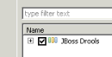

## Click on the checkbox, then “Next” at the bottom of screen, giving you this:

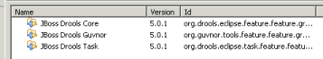

## Click “Next” again, and you get the following screen:

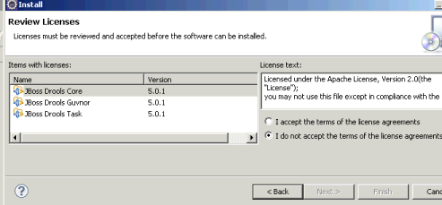

## Click on “I accept the terms of the license agreements” and then click on “Finish”

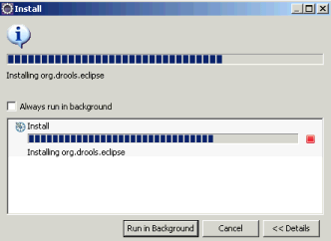

## You will see a progress bar during the installation, and you may get the following warning, to which you should click “OK”

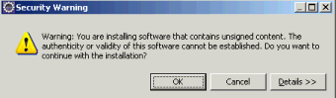

## Finally, you will need to restart Eclipse:

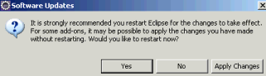

## Restart Eclipse, and you should see that your Window / Preferences menu now shows the following

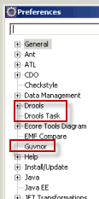

## Open the Drools menu and click on “Installed Drools Runtimes”

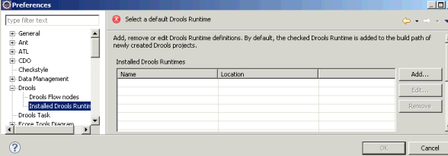

## Click on the “Add…” button and